**4 Tricks and Tips for Kindergarten First-Timers**

*Lessons I learned as mom to a first-year student.*

1. **Starting full-day kindergarten can be hard—for everyone.** Kids and parents (and teachers!) need a few weeks to adjust. Beyond the emotions around starting school, kindergarten is downright tiring. My son returned home exhausted in the first few weeks. Days are packed with learning and playing, sitting still and dancing, letters and line manners, as well as getting to know classmates and teachers.

**>> TIP*:*** *Allow yourself and your child time to settle in to the new schedule. Consider moving up bedtime to help your child get plenty of rest. Help your little one be at his or her best with a nutritious breakfast. Don’t forget to pack a lunch and a snack for afternoon.*

1. **Embrace the schedule—whether it’s hourly, daily, or weekly.** A large part of getting used to kindergarten is getting used to the day-to-day schedule—plus the fact that it returns *every* day for *five* days in a row! My son was just as skeptical about his six-hour school day as most of us new parents were about a 20-minute lunch. (20 minutes?! How can our kids possibly get settled down and eat an entire lunch in 20 minutes?)   
     
   Yes, days are long, but they are broken up into bite-sized chunks. Over time, most kindergartners do get used to the daily schedule and even take pride in being able to tell you the classroom agenda.

**>> TIP:** *If your child is really struggling to last through the day, rest assured that teachers have plenty of tricks to help. Some kids may benefit from seeing their day spelled out hour by hour. And for kids who struggle to make it through the week, tricks like count-down paper chains at home can help them visualize the Friday finish-line.* (*Oh, and yes, somehow the kids do get used to eating in the time they are given!)*

1. **Independence is a good thing.** If you’re like most parents, the process of leaving the house can be a true test of patience. Now, just imagine getting *20 kids* ready and out the door! At school, kids move to other classrooms, the lunch room, and outdoor recess. Prepare your child for greater independence during the months leading up to school to make these transitions easier. Doing so can help ease the stress of daily tasks for your little one, other kids, as well as teachers.

**>> TIP:** *Think through a typical day at school and ask yourself if your child can manage the necessary tasks. For example: Can your child zip his coat? After using the restroom, will she be able to pull up her tights? If you’ve braved the world of shoe laces, can your child tie them himself? If you’re sending your child to school with the latest Bento lunch box, can she open it by herself?*

1. **Knowing your entrances, exits, and support options is key.** Depending on which elementary school your little one is attending, your before- and after-school care, and your transportation options, pick-up and drop-off can look very different for each child.   
     
   Since we live close to school, the bus wasn’t an option and we entered the “walker” category. We drop off our son outside of one door (parents aren’t permitted to enter the school or bring kids to the classroom). At the end of the day, we can pick him up either by signing him out in the cafeteria or from outside the school, where kids are released by a monitor.   
     
   Rest assured that the elementary staff is incredibly good at getting to know our children. I was impressed at how quickly various school helpers and staff knew my son’s name. And I remain infinitely grateful for their support on the days my son simply refused to walk into school. There was always a kind staff member willing to offer the right encouragement and bring him directly to class.

**>> TIP:** *Whether your child is a walker, being dropped off by car, or taking a bus, be sure you know the right place to drop off and pick up your child. Not sure? Call the attendance office at your school or the transportation office. You can find the numbers in the school calendar or online, https://www.bscsd.org.*

***BONUS* FACTS & TIPS**

**Quiet time, not nap time**

Most kindergarteners won’t have the option for a nap during the day. Instead, they will have quiet time, when kids can choose from various quiet activities, including resting their head.

**Half day, huh?**

Half days for elementary school officially end at 11:45. However, be aware that if you’re picking up your little one from school, dismissal can begin as early as 11:30.

**Library lessons**

You may hear from your child that “library” is only a few books on a small shelf. Rather than giving the little ones free rein over the entire library, they help the kids get used to the process of choosing and checking out books by first limiting their options. Little by little, the options grow. From the school’s website: “Students visit the library weekly to borrow and return materials. Students may select one item that they may keep for the week, with a total of two items allowed out at a time. Materials are due in one week and may be renewed if not on hold for another student.”

**Music notes**

Don’t be surprised if your kindergartner isn’t trying their hands at violins, tubas, or tom-toms during the first months of school. Like the other humanities (including art, gym, computer lab, and library), music class may start slowly and grow to incorporate more hands-on work. Elementary students won’t typically use an instrument until fourth grade.

**Recess rules**

Depending on your school, you may notice that the first few weeks of recess don’t take place on what’s considered the “prime” playground. My son (and husband) was disappointed that he wasn’t playing on what he thought was *the best* playground. It turns out, they often start the kindergarteners in a more basic play area just until everybody gets used to the schedule and the new environment. (Like I said, getting used to kindergarten takes time!). On rainy or very cold days, kids will typically spend recess either in the gym or their classroom.

**Lunch and snacks:** Kids bring lunches and snacks (never including candy) or buy food in the cafeteria. Send your child with a lunch sack in addition to a separate snack bag (for the snacktime they have in the classroom). If buying lunch, your child can use cash or the online payment system (which requires his or her ID code). Lunch staff are on hand to help out—whether it’s opening a tricky container or typing in the code. If kids forget their code or their lunch, don’t worry. There is always a helping hand who can make sure our kids don’t go hungry. Learn more about lunches and view the cafeteria menu here: https://ny02211965.schoolwires.net/domain/34.

**Birthday bash:** Check with your teacher, but in general, kids may bring in a treat on their birthday. There is no candy or baked items allowed, so consider individual bags of snacks (fruit snacks, cheese puffs, or popcorn, for example) or favor bags with stickers or pencils.

**TERMS TO LEARN**

Like most school districts, ours has its own language and vocabulary words. Be sure to ask if you don’t understand anything, but here are few terms that I stumbled over:

**The Complex:** This is a term for Gordon Creek, Wood Road, and Milton Terrace Schools.

**Dojo:** ClassDojo is a classroom communication app used to share reports between parents and teachers. Some teachers in the school district use the app to track student behavior using points.

**Student ID:** This four- or five-digit code will be connected to your child throughout his or her time at school. It’s also the code kids enter into the cafeteria’s number pad to pay for lunch or snacks.

**Absences:** There are two kinds of absences in school—excused and unexcused. Excused absences include sick days or appointments, including visits to the doctor or dentist. Unexcused absences are generally anything else—those optional outs, like tea parties at grandma’s or family vacations. Because they want to make sure our kids are getting as much time as possible in class to learn and grow, the school hopes to limit those unexcused days out.

Also, I found this guide very helpful when it came to deciding whether I needed to keep our son home due to illness:

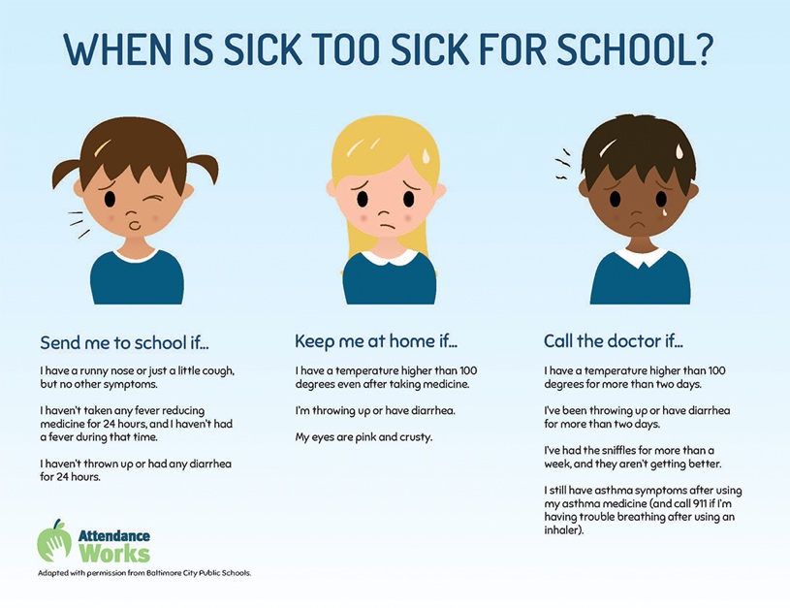

**Lockdowns and Lockouts:** One of the hardest realities of school today is the need to prepare kids for potential safety issues. The elementary teachers and staff are well-trained in practicing age-appropriate safety drills without causing unnecessary stress or fear in the kids.

Of course, every child and every parent is different. To speak in more detail about safety issues, consider reaching out to your child’s teacher or the principal. Learn more about student safety matters at www.bscsd.org/domain/47.

You will receive an automated message from the SchoolMessenger system if your child’s school is in a lockdown or lockout. An additional message will be sent once the school has resumed normal activities. Here are some basics:

* + **A lockdown** is done to protect students from potential threats inside the school.
  + **A lockout** is done to protect students from potential threats outside the school. Generally, lockouts are more common because they go into effect when there are threats of any kind in the community or district. For example, a lockout may occur if a fox is seen in neighboring streets or if there is a robbery committed in Ballston Spa.

**SchoolMessenger System:** This is an automated notification system which allows the district to contact parents with related news, district emergencies and closing or delay information. Learn more about the system—including how to opt for text messaging—at www.bscsd.org/domain/45.